Obs | id | class | gender | exam1 | exam2
1 | 101 | 1 | M | 80 | 80
2 | 102 | 2 | M | 90 | 97
3 | 103 | 1 | M | 66 | 44
4 | 104 | 2 | M | 56 | 59
5 | 105 | 1 | M | 100 | 75
6 | 106 | 2 | F | 99 | 68
7 | 107 | 1 | F | 87 | 78
8 | 108 | 2 | F | 78 | 77
9 | 109 | 1 | F | 90 | 72
10 | 110 | 2 | F | 83 | 67

Obs | id | class | gender | exam1 | exam2
4 | 104 | 2 | M | 56 | 59
6 | 106 | 2 | F | 99 | 68
8 | 108 | 2 | F | 78 | 77
10 | 110 | 2 | F | 83 | 67

class=1

Obs | id | gender | exam1 | exam2
1 | 101 | M | 80 | 80
2 | 103 | M | 66 | 44
3 | 105 | M | 100 | 75
4 | 107 | F | 87 | 78
5 | 109 | F | 90 | 72
class |  |  | 423 | 349

class=2

Obs | id | gender | exam1 | exam2
6 | 102 | M | 90 | 97
7 | 104 | M | 56 | 59
8 | 106 | F | 99 | 68
9 | 108 | F | 78 | 77
10 | 110 | F | 83 | 67
class |  |  | 406 | 368
 |  |  | 829 | 717
Variable | N | Mean | Std Dev | Minimum | Maximum
exam1  exam2 | 10  10 | 82.90  71.70 | 13.79  13.95 | 56.00  44.00 | 100.00  97.00

Moments
N | 10 | Sum Weights | 10
Mean | 82.9 | Sum Observations | 829
Std Deviation | 13.7876757 | Variance | 190.1
Skewness | -0.7670691 | Kurtosis | 0.27419567
Uncorrected SS | 70435 | Corrected SS | 1710.9
Coeff Variation | 16.6316956 | Std Error Mean | 4.36004587

Basic Statistical Measures
Location |  | Variability
Mean | 82.90000 | Std Deviation | 13.78768
Median | 85.00000 | Variance | 190.10000
Mode | 90.00000 | Range | 44.00000
 |  | Interquartile Range | 12.00000

Tests for Location: Mu0=0
Test | Statistic |  | p Value
Student's t | t | 19.01356 | Pr > |t| | <.0001
Sign | M | 5 | Pr >= |M| | 0.0020
Signed Rank | S | 27.5 | Pr >= |S| | 0.0020

Quantiles (Definition 5)
Level | Quantile
100% Max | 100.0
99% | 100.0
95% | 100.0
90% | 99.5
75% Q3 | 90.0
50% Median | 85.0
25% Q1 | 78.0
10% | 61.0
5% | 56.0
1% | 56.0
0% Min | 56.0

Extreme Observations
Lowest |  | Highest
Value | Obs | Value | Obs
56 | 4 | 87 | 7
66 | 3 | 90 | 2
78 | 8 | 90 | 9
80 | 1 | 99 | 6
83 | 10 | 100 | 5

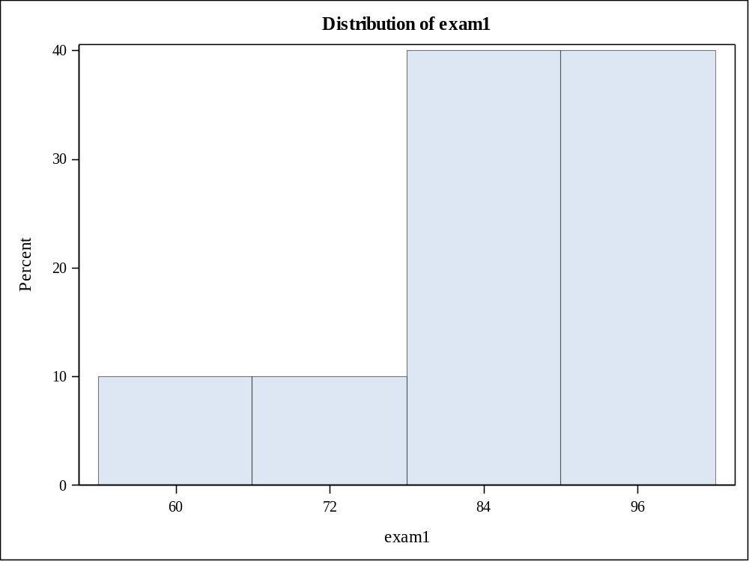
Moments
N | 10 | Sum Weights | 10
Mean | 71.7 | Sum Observations | 717
Std Deviation | 13.9526979 | Variance | 194.677778
Skewness | -0.3198737 | Kurtosis | 1.60587814
Uncorrected SS | 53161 | Corrected SS | 1752.1
Coeff Variation | 19.4598297 | Std Error Mean | 4.41223048

Basic Statistical Measures
Location |  | Variability
Mean | 71.70000 | Std Deviation | 13.95270
Median | 73.50000 | Variance | 194.67778
Mode | . | Range | 53.00000
 |  | Interquartile Range | 11.00000

Tests for Location: Mu0=0
Test | Statistic |  | p Value
Student's t | t | 16.25028 | Pr > |t| | <.0001
Sign | M | 5 | Pr >= |M| | 0.0020
Signed Rank | S | 27.5 | Pr >= |S| | 0.0020

Quantiles (Definition 5)
Level | Quantile
100% Max | 97.0
99% | 97.0
95% | 97.0
90% | 88.5
75% Q3 | 78.0
50% Median | 73.5
25% Q1 | 67.0
10% | 51.5
5% | 44.0
1% | 44.0
0% Min | 44.0

Extreme Observations
Lowest |  | Highest
Value | Obs | Value | Obs
44 | 3 | 75 | 5
59 | 4 | 77 | 8
67 | 10 | 78 | 7
68 | 6 | 80 | 1
72 | 9 | 97 | 2

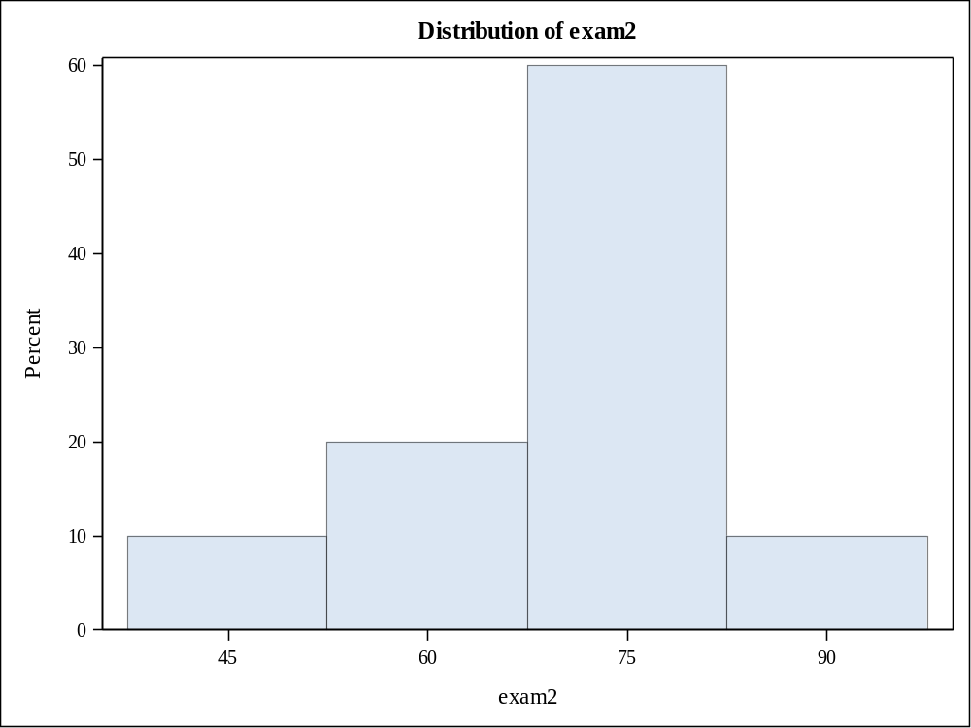
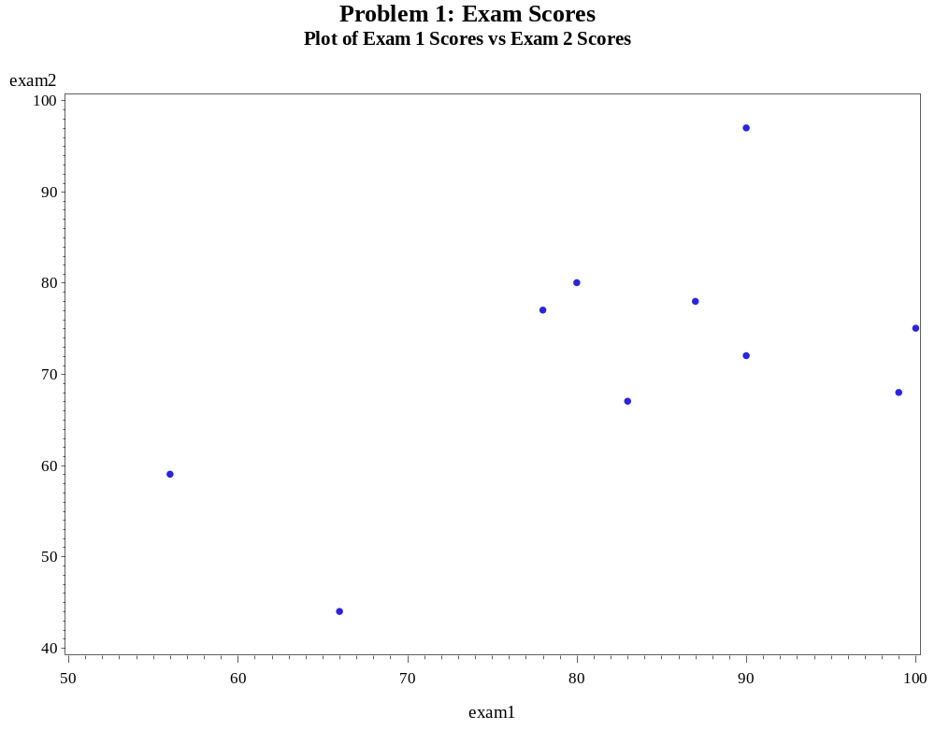
2 Variables: | exam1 exam2

Simple Statistics
Variable | N | Mean | Std Dev | Sum | Minimum | Maximum
exam1 | 10 | 82.90000 | 13.78768 | 829.00000 | 56.00000 | 100.00000
exam2 | 10 | 71.70000 | 13.95270 | 717.00000 | 44.00000 | 97.00000

Pearson Correlation Coefficients, N = 10
Prob > |r| under H0: Rho=0
 | exam1 | exam2
exam1 | 1.00000 | 0.55661  0.0947
exam2 | 0.55661  0.0947 | 1.00000
N | Mean | Std Dev | Std Err | Minimum | Maximum
10 | 11.2000 | 13.0622 | 4.1306 | -7.0000 | 31.0000

Mean | 95% CL Mean |  | Std Dev | 95% CL Std Dev
11.2000 | 1.8558 | 20.5442 | 13.0622 | 8.9847 | 23.8466

DF | t Value | Pr > |t|
9 | 2.71 | 0.0239

